Create a custom docker image for nginx and deploy it using docker-compose, where the volume mount should be at /var/opt/nginx location. Push the created custom docker image to your docker hub.

First, I have used docker from my previously installed ubuntu instance

* Created a Dockerfile for Nginx with following commands (Content)

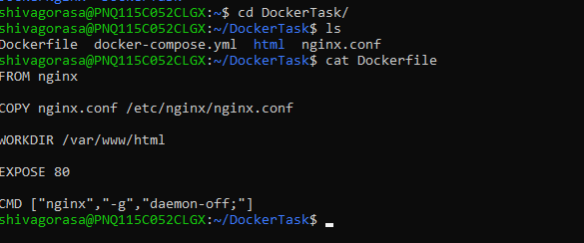

* Next I have created a custom nginx.conf with message as following

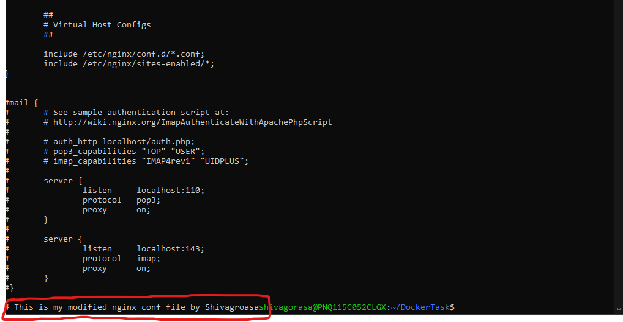

* Next, I have created a docker-compose.yml file with following content

Here instead of /var/www/html we can replace with /var/opt/nginx under volumes for volume mount

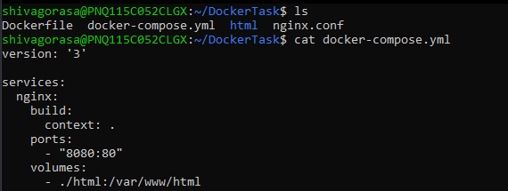

* Then in terminal ran following commands
  + docker-compose build

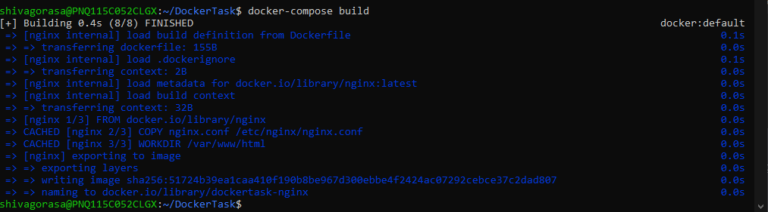

* + docker-compose up -d



* Verified Nginx container Running



**Used Following command to Tag my custom created Image**

docker tag dockertask-nginx:latest shivagorasa1/dockertask-nginx:latest

**Pushed custom nginx image with tag:latest to my docker hub repo using following command**

docker push shivagorasa1/dockertask-nginx:latest

which can be verified with following link

<https://hub.docker.com/repository/docker/shivagorasa1/dockertask-nginx/general>

